AESTHETIC MAN
New Book Published This Week

A book published this week is a motivational, spiritual, philosophical and practical compass for the 21st century man.

Aesthetic Man explores the symbiotic relationship between various elements of a man’s life including personality, general health, awareness, relaxation, relationships, skincare, fitness, cuisine and more. At the heart of the book is a simple truth: the elements of our lives are not isolated. They are symbiotic—interdependent, complementary and powerful when in balance.

Aesthetic Man explains the links between a man’s daily routine. It eliminates the ego-centric stigma associated with spending time and effort in looking after oneself and instead, looks at how those efforts can affect a man and everyone around him.

Said author Paul Olavesen-Stabb: “Aesthetic Man aims to resonate and shape men’s perspectives, incentivising them to consider the way they think and act. The overarching red threads are balance and symbiosis, two of my favourite words in the English language. A man creates balance in all elements of his life, with symbiosis extending that balance. This is especially relevant given the high-octane environment in which we all currently live.

Paul added: “There are several external forces which can affect the Aesthetic Man lifestyle, and age is not one of them. It’s neither too early nor too late to adopt a healthier way of living. Brain power, strength, flexibility of joints, memory, libido and skin condition can all deteriorate with age, and a man can take firm and decisive action to hold off these negative changes for as long as possible.

Aesthetic Man is very much a personal journey which I would like to share, and I hope that the book will be equally of interest to both men and women.”

NOTES FOR EDITORS

Paul Olavesen-Stabb is a British film producer, writer and inspirational speaker at Aetheris Films and Aetheris Publishing. His first novel Attagirls was published in 2021 and is based on the female pilots of the Air Transport Auxiliary (‘ATA’) during the Second World War. He is looking to produce the feature film.

Paul started his production career as the founder of Bahama Locations, a Caribbean-based agency for location management and reduction of production budget lines via contras. He was thereafter co-founder and Executive Producer at Ritz Entertainment in L.A. He has over 25 years of experience as an Executive Producer / Director and screenwriter with a career spanning the UK, Norway, USA and Caribbean. He is finance focused and holds a double Masters Degree in Business (MBA hons) from ESCP-EAP, Paris - one of Europe's leading business schools.

Paul is also the Group CEO of the MÖ Scandinavia Group of Companies, his family’s international business, which is thirty years old. The companies comprise the manufacture and sale of medical and aesthetic equipment, as well as cosmeceutical products; aesthetic skincare training academies; aesthetic consultancy; and clinic ownership, management and franchising across Norway, Denmark and the UK.

Aesthetic Man will be available in bookshops across the UK from 15th December 2025.

MEDIA ENQUIRES:
Paul Olavesen-Stabb / Aetheris Publishing Ltd
UK +44 (0) 7711 086227 / Norway +47 46 884 884
paul@aetheris.co.uk / www.aetheris.co.uk



www.aetheris.co.uk

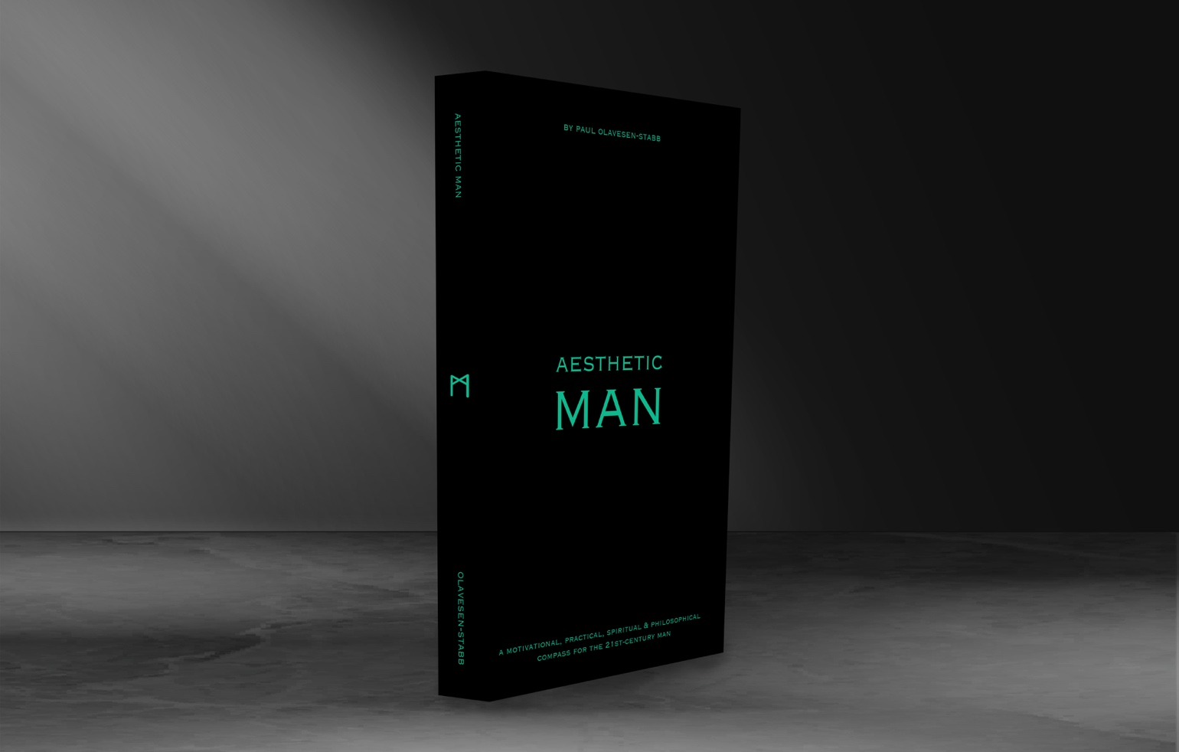



Hi-res images available

